



**자바 프로그래밍 1분반**

Lab 3



32241484 류지성

2025-04-11

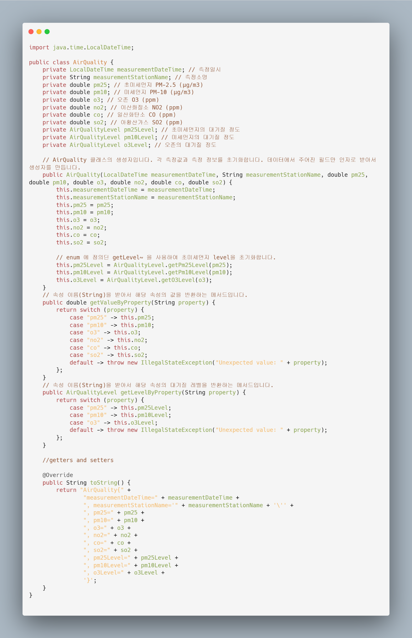

AirQuality 메서드 입니다. 측정일시, 측정장소, 초미세먼지, 미세먼지, 오존, 이산화질소, 일산화탄소, 아황산 가스를 멤버로 가지고 있고, 초미세먼지, 미세먼지, 오존의 각 대기질 정도 또한 멤버로 가지고 있습니다. 생성자는 파싱할 때 내용을 담기 편하도록 원본 데이터의 순서대로 배치했습니다. Level에 대한 멤버들은 AirQualityLevel Enum 에 정의된 메서드를 통하여 초기화를 해줍니다. getValueByProperty 랑 getLevelByProperty 메서드가 있는데, 각각은 원하는 속성을 문자열로 받아서 그에 맞는 값이나 공기질 단계를 반환하는 메서드 입니다. Getter and setter는 공간이 부족하여 생략했습니다.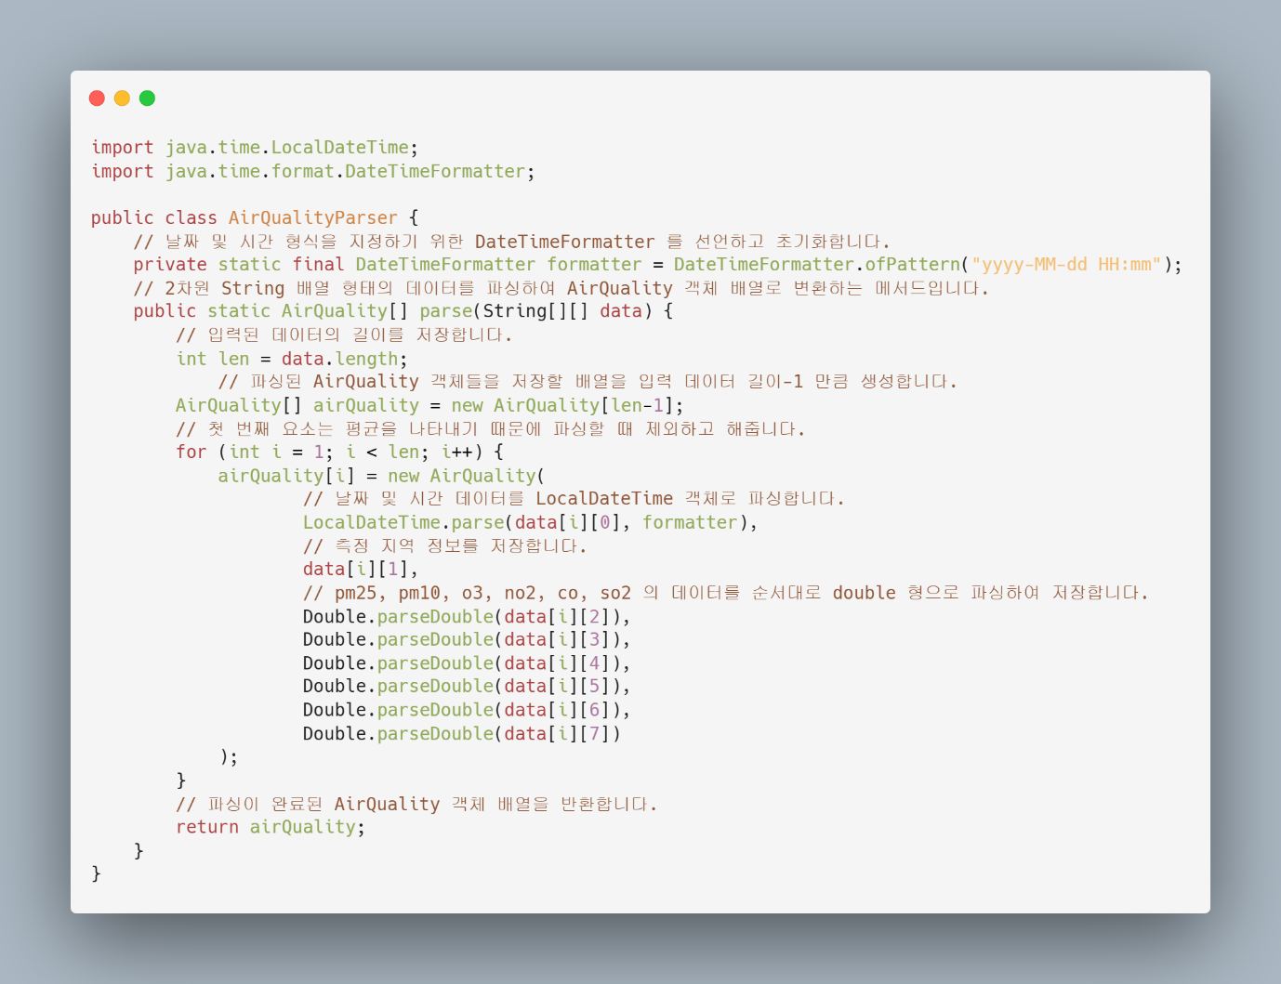

AirQualityParser 클래스 입니다. 이 클래스는 유틸리티 클래스로 주어진 String[][] 의 데이터를 파싱하여 AirQuality[] 를 반환합니다.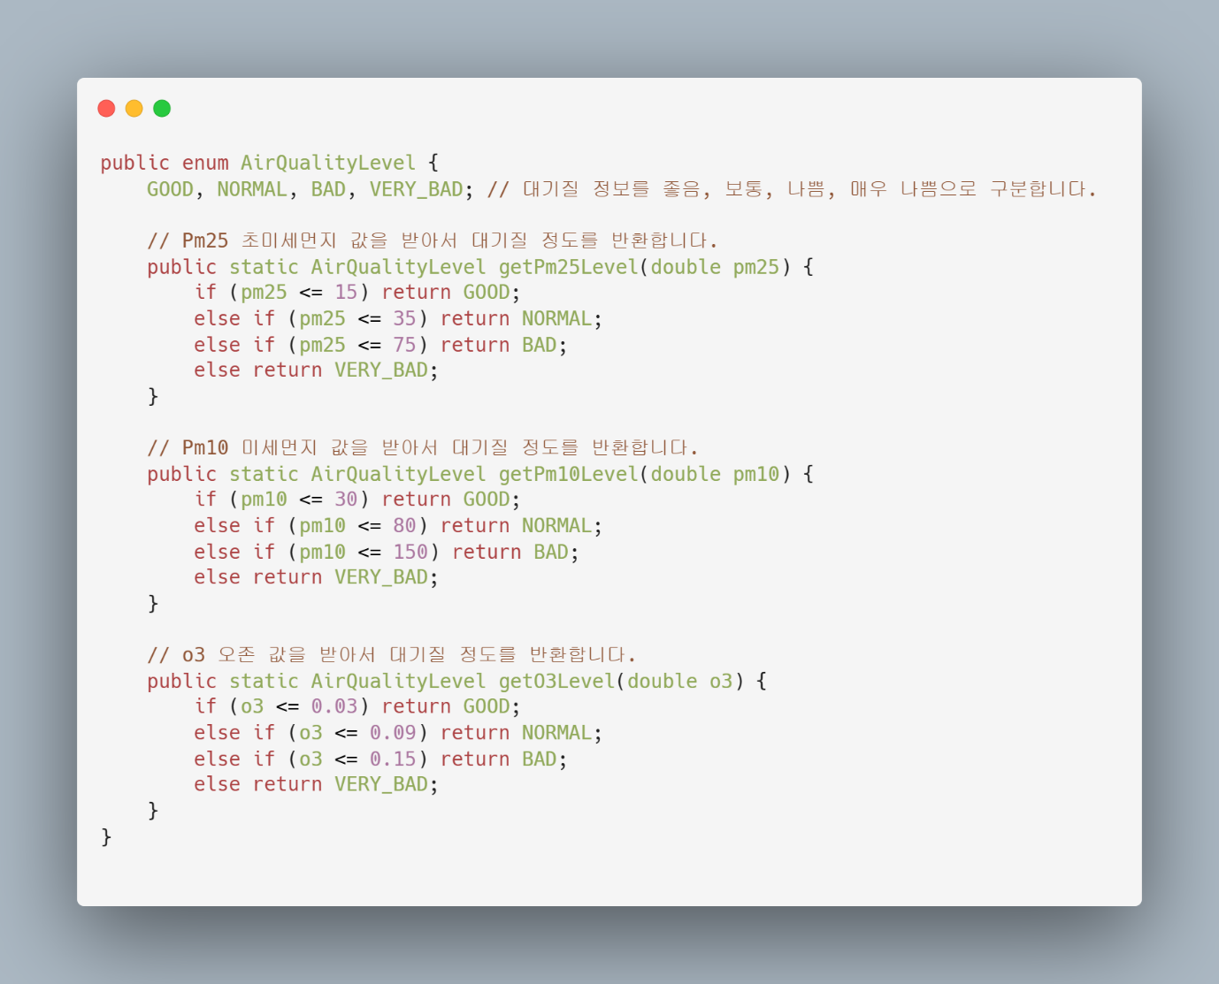

위 코드는 AirQualityLevel enum 입니다. GOOD, NORMAL, BAD, VERY_BAD 으로 좋음, 보통, 나쁨, 매우 나쁨을 표현합니다. 초미세먼지, 미세먼지, 오존에 관해서만 자세한 분류가 나와있기에 이 세 가지에 대해서 Level 을 반환하는 메서드들을 만들어서, 초기화 과정에서 수치를 입력하면 그에 해당하는 대기 수준을 알 수 있습니다.

아래 코드는 AirQualityFinder 클래스 입니다. 기본적인 find 함수는 파싱한 AirQuality[와 원하는 초미세먼지와 미세먼지의 범위를 인자로 받습니다. 이후에 몇 개의 값이 해당될 지 모르기 때문에 동적배열인 ArrayList 를 선언해줍니다. 파싱한 data 들을 전부 순회하면서 해당되는 범위 내에 속하면 ArrayList 에 추가를 합니다. 최종적으로는 .toArray 메서드를 사용하여 AirQuality[] 형태로 변환하여 반환합니다. toArray에 new AirQuality[0]을 전달하는 이유는 반환될 배열의 타입을 지정하기 위해서입니다. findByRange 는 double 형의 값을 가진 AirQuality 의 멤버들에 대해서 범위를 전달 받아서 위와 같은 find 를 하는 메서드이고, findByLevel 은 특정 멤버의 대기 수준을 통해 위와 같이 find 하는 메서드입니다.

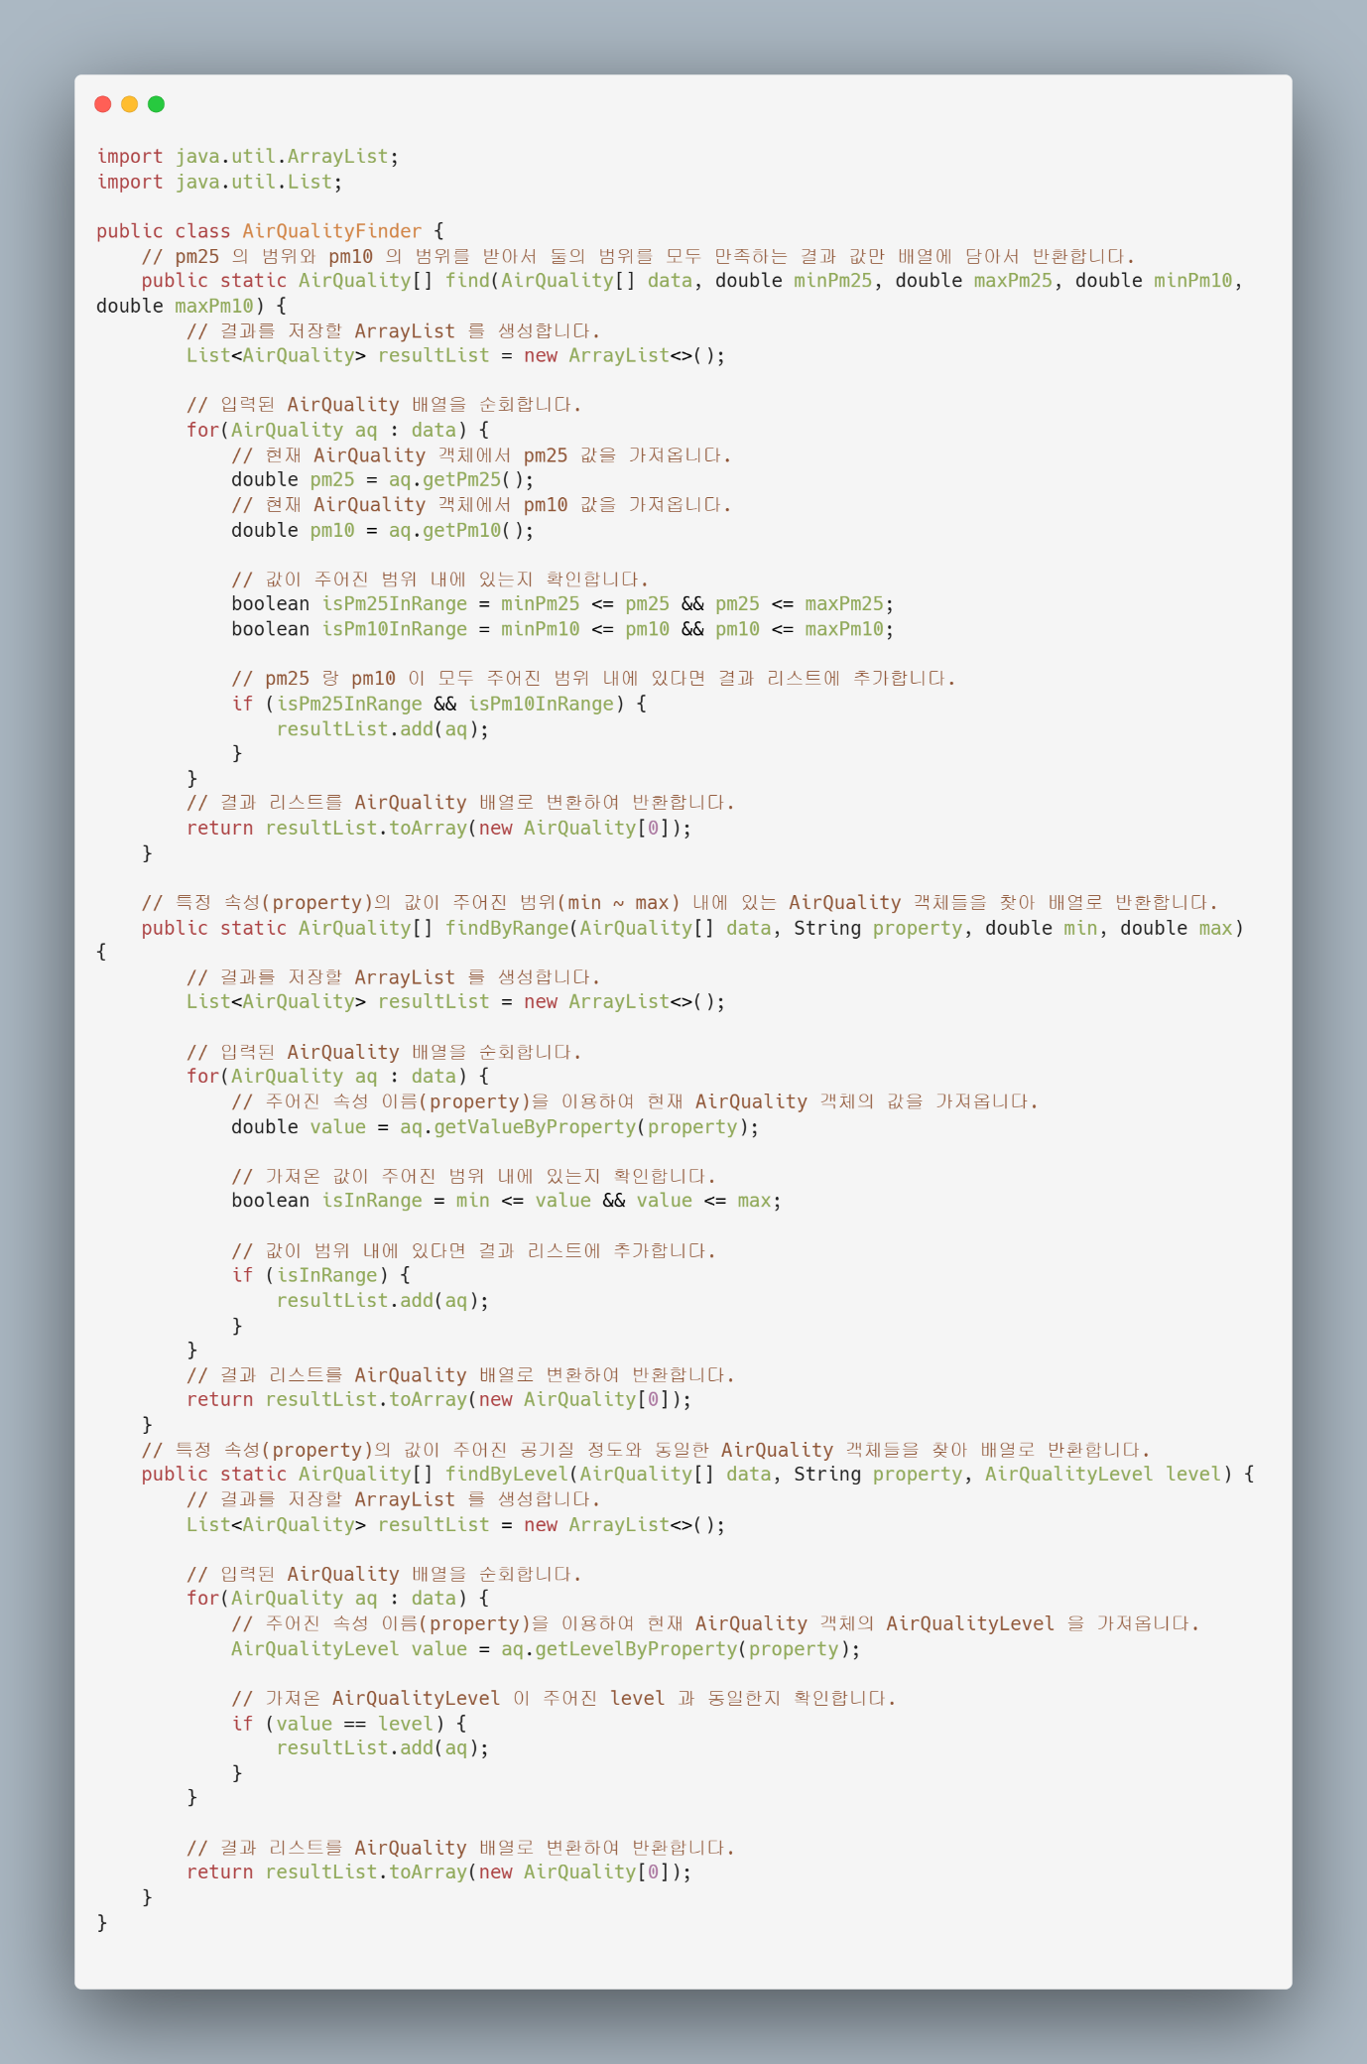

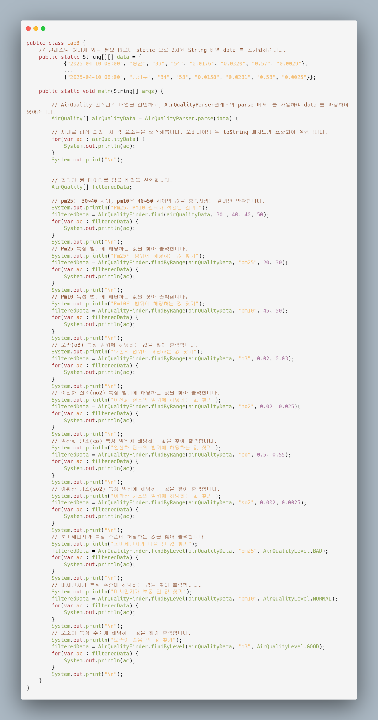

Lab3 클래스 입니다. main 함수가 정의되어있어 프로그램의 진입점이 됩니다. Data 는 너무 길어져서 중간에 자른 형태로 캡쳐했습니다. AirQuality 인스턴스 배열을 선언하고, AirQualityParser클래스의 parse 메서드를 사용하여 data 를 파싱하여 넣어줍니다. 제대로 파싱이 되었는지 파싱된 데이터들을 순회하면서 출력을 해줍니다. 이후에는 filteredData 를 선언하여 find 함수의 반환값을 받아줍니다. AirQualityFinder 클래스의 find 메서드를 사용하여 pm25는 30~40 사이, pm10은 40~50 사이의 값을 충족시키는 결과를 받아 출력합니다. 이후에는 findByRange, findByLevel 으로 해당하는 값들을 찾아 볼 수 있습니다. 아래는 실행 결과 입니다.

c:\Users\Lenovo\Documents\GitHub\Learning-Java\Lab3\src>cd "c:\Users\Lenovo\Documents\GitHub\Learning-Java\Lab3\src\" && javac -d ../bin Lab3.java && java -cp ../bin Lab3 AirQuality{measurementDateTime=2025-04-10T08:00, measurementStationName='평균', pm25=39.0, pm10=54.0, o3=0.0176, no2=0.032, co=0.57, so2=0.0029, pm25Level=BAD, pm10Level=NORMAL, o3Level=GOOD} AirQuality{measurementDateTime=2025-04-10T08:00, measurementStationName='강남구', pm25=44.0, pm10=59.0, o3=0.0177, no2=0.0356, co=0.5, so2=0.0024, pm25Level=BAD, pm10Level=NORMAL, o3Level=GOOD} AirQuality{measurementDateTime=2025-04-10T08:00, measurementStationName='강동구', pm25=41.0, pm10=56.0, o3=0.0116, no2=0.0387, co=0.77, so2=0.0026, pm25Level=BAD, pm10Level=NORMAL, o3Level=GOOD} AirQuality{measurementDateTime=2025-04-10T08:00, measurementStationName='강북구', pm25=31.0, pm10=40.0, o3=0.0282, no2=0.0204, co=0.49, so2=0.0024, pm25Level=NORMAL, pm10Level=NORMAL, o3Level=GOOD} AirQuality{measurementDateTime=2025-04-10T08:00, measurementStationName='강서구', pm25=41.0, pm10=61.0, o3=0.0095, no2=0.0422, co=0.56, so2=0.0039, pm25Level=BAD, pm10Level=NORMAL, o3Level=GOOD} AirQuality{measurementDateTime=2025-04-10T08:00, measurementStationName='관악구', pm25=32.0, pm10=42.0, o3=0.0141, no2=0.0407, co=0.62, so2=0.0029, pm25Level=NORMAL, pm10Level=NORMAL, o3Level=GOOD} AirQuality{measurementDateTime=2025-04-10T08:00, measurementStationName='광진구', pm25=38.0, pm10=52.0, o3=0.0165, no2=0.0361, co=0.59, so2=0.0028, pm25Level=BAD, pm10Level=NORMAL, o3Level=GOOD} AirQuality{measurementDateTime=2025-04-10T08:00, measurementStationName='구로구', pm25=50.0, pm10=57.0, o3=0.017, no2=0.0299, co=0.47, so2=0.0028, pm25Level=BAD, pm10Level=NORMAL, o3Level=GOOD} AirQuality{measurementDateTime=2025-04-10T08:00, measurementStationName='금천구', pm25=36.0, pm10=55.0, o3=0.0102, no2=0.0481, co=0.56, so2=0.0031, pm25Level=BAD, pm10Level=NORMAL, o3Level=GOOD} AirQuality{measurementDateTime=2025-04-10T08:00, measurementStationName='노원구', pm25=36.0, pm10=51.0, o3=0.0161, no2=0.0333, co=0.58, so2=0.0028, pm25Level=BAD, pm10Level=NORMAL, o3Level=GOOD} AirQuality{measurementDateTime=2025-04-10T08:00, measurementStationName='도봉구', pm25=34.0, pm10=50.0, o3=0.0272, no2=0.0225, co=0.61, so2=0.0033, pm25Level=NORMAL, pm10Level=NORMAL, o3Level=GOOD} AirQuality{measurementDateTime=2025-04-10T08:00, measurementStationName='동대문구', pm25=41.0, pm10=60.0, o3=0.0207, no2=0.0261, co=0.56, so2=0.0025, pm25Level=BAD, pm10Level=NORMAL, o3Level=GOOD} AirQuality{measurementDateTime=2025-04-10T08:00, measurementStationName='동작구', pm25=39.0, pm10=54.0, o3=0.0269, no2=0.0296, co=0.49, so2=0.0028, pm25Level=BAD, pm10Level=NORMAL, o3Level=GOOD} AirQuality{measurementDateTime=2025-04-10T08:00, measurementStationName='마포구', pm25=40.0, pm10=46.0, o3=0.0219, no2=0.0233, co=0.5, so2=0.0029, pm25Level=BAD, pm10Level=NORMAL, o3Level=GOOD} AirQuality{measurementDateTime=2025-04-10T08:00, measurementStationName='서대문구', pm25=42.0, pm10=52.0, o3=0.0162, no2=0.0255, co=0.74, so2=0.0041, pm25Level=BAD, pm10Level=NORMAL, o3Level=GOOD} AirQuality{measurementDateTime=2025-04-10T08:00, measurementStationName='서초구', pm25=47.0, pm10=68.0, o3=0.0143, no2=0.0363, co=0.5, so2=0.0025, pm25Level=BAD, pm10Level=NORMAL, o3Level=GOOD} AirQuality{measurementDateTime=2025-04-10T08:00, measurementStationName='성동구', pm25=42.0, pm10=56.0, o3=0.0143, no2=0.0354, co=0.52, so2=0.0025, pm25Level=BAD, pm10Level=NORMAL, o3Level=GOOD} AirQuality{measurementDateTime=2025-04-10T08:00, measurementStationName='성북구', pm25=33.0, pm10=49.0, o3=0.0239, no2=0.0235, co=0.66, so2=0.0031, pm25Level=NORMAL, pm10Level=NORMAL, o3Level=GOOD} AirQuality{measurementDateTime=2025-04-10T08:00, measurementStationName='송파구', pm25=32.0, pm10=49.0, o3=0.0139, no2=0.0413, co=0.51, so2=0.0038, pm25Level=NORMAL, pm10Level=NORMAL, o3Level=GOOD} AirQuality{measurementDateTime=2025-04-10T08:00, measurementStationName='양천구', pm25=43.0, pm10=62.0, o3=0.01, no2=0.0422, co=0.6, so2=0.0032, pm25Level=BAD, pm10Level=NORMAL, o3Level=GOOD} AirQuality{measurementDateTime=2025-04-10T08:00, measurementStationName='영등포구', pm25=42.0, pm10=51.0, o3=0.0149, no2=0.0342, co=0.55, so2=0.0026, pm25Level=BAD, pm10Level=NORMAL, o3Level=GOOD} AirQuality{measurementDateTime=2025-04-10T08:00, measurementStationName='용산구', pm25=41.0, pm10=56.0, o3=0.0155, no2=0.0323, co=0.56, so2=0.0034, pm25Level=BAD, pm10Level=NORMAL, o3Level=GOOD} AirQuality{measurementDateTime=2025-04-10T08:00, measurementStationName='은평구', pm25=38.0, pm10=53.0, o3=0.0108, no2=0.0272, co=0.68, so2=0.0028, pm25Level=BAD, pm10Level=NORMAL, o3Level=GOOD} AirQuality{measurementDateTime=2025-04-10T08:00, measurementStationName='종로구', pm25=43.0, pm10=59.0, o3=0.0246, no2=0.0243, co=0.56, so2=0.0029, pm25Level=BAD, pm10Level=NORMAL, o3Level=GOOD} AirQuality{measurementDateTime=2025-04-10T08:00, measurementStationName='중구', pm25=43.0, pm10=53.0, o3=0.028, no2=0.0225, co=0.56, so2=0.0024, pm25Level=BAD, pm10Level=NORMAL, o3Level=GOOD} AirQuality{measurementDateTime=2025-04-10T08:00, measurementStationName='중랑구', pm25=34.0, pm10=53.0, o3=0.0158, no2=0.0281, co=0.53, so2=0.0025, pm25Level=NORMAL, pm10Level=NORMAL, o3Level=GOOD} Pm25, Pm10 필터가 적용된 결과. AirQuality{measurementDateTime=2025-04-10T08:00, measurementStationName='강북구', pm25=31.0, pm10=40.0, o3=0.0282, no2=0.0204, co=0.49, so2=0.0024, pm25Level=NORMAL, pm10Level=NORMAL, o3Level=GOOD} AirQuality{measurementDateTime=2025-04-10T08:00, measurementStationName='관악구', pm25=32.0, pm10=42.0, o3=0.0141, no2=0.0407, co=0.62, so2=0.0029, pm25Level=NORMAL, pm10Level=NORMAL, o3Level=GOOD} AirQuality{measurementDateTime=2025-04-10T08:00, measurementStationName='도봉구', pm25=34.0, pm10=50.0, o3=0.0272, no2=0.0225, co=0.61, so2=0.0033, pm25Level=NORMAL, pm10Level=NORMAL, o3Level=GOOD} AirQuality{measurementDateTime=2025-04-10T08:00, measurementStationName='마포구', pm25=40.0, pm10=46.0, o3=0.0219, no2=0.0233, co=0.5, so2=0.0029, pm25Level=BAD, pm10Level=NORMAL, o3Level=GOOD} AirQuality{measurementDateTime=2025-04-10T08:00, measurementStationName='성북구', pm25=33.0, pm10=49.0, o3=0.0239, no2=0.0235, co=0.66, so2=0.0031, pm25Level=NORMAL, pm10Level=NORMAL, o3Level=GOOD} AirQuality{measurementDateTime=2025-04-10T08:00, measurementStationName='송파구', pm25=32.0, pm10=49.0, o3=0.0139, no2=0.0413, co=0.51, so2=0.0038, pm25Level=NORMAL, pm10Level=NORMAL, o3Level=GOOD} Pm25의 범위에 해당하는 값 찾기 Pm10의 범위에 해당하는 값 찾기 AirQuality{measurementDateTime=2025-04-10T08:00, measurementStationName='도봉구', pm25=34.0, pm10=50.0, o3=0.0272, no2=0.0225, co=0.61, so2=0.0033, pm25Level=NORMAL, pm10Level=NORMAL, o3Level=GOOD} AirQuality{measurementDateTime=2025-04-10T08:00, measurementStationName='마포구', pm25=40.0, pm10=46.0, o3=0.0219, no2=0.0233, co=0.5, so2=0.0029, pm25Level=BAD, pm10Level=NORMAL, o3Level=GOOD} AirQuality{measurementDateTime=2025-04-10T08:00, measurementStationName='성북구', pm25=33.0, pm10=49.0, o3=0.0239, no2=0.0235, co=0.66, so2=0.0031, pm25Level=NORMAL, pm10Level=NORMAL, o3Level=GOOD} AirQuality{measurementDateTime=2025-04-10T08:00, measurementStationName='송파구', pm25=32.0, pm10=49.0, o3=0.0139, no2=0.0413, co=0.51, so2=0.0038, pm25Level=NORMAL, pm10Level=NORMAL, o3Level=GOOD} 오존의 범위에 해당하는 값 찾기 AirQuality{measurementDateTime=2025-04-10T08:00, measurementStationName='강북구', pm25=31.0, pm10=40.0, o3=0.0282, no2=0.0204, co=0.49, so2=0.0024, pm25Level=NORMAL, pm10Level=NORMAL, o3Level=GOOD} AirQuality{measurementDateTime=2025-04-10T08:00, measurementStationName='도봉구', pm25=34.0, pm10=50.0, o3=0.0272, no2=0.0225, co=0.61, so2=0.0033, pm25Level=NORMAL, pm10Level=NORMAL, o3Level=GOOD} AirQuality{measurementDateTime=2025-04-10T08:00, measurementStationName='동대문구', pm25=41.0, pm10=60.0, o3=0.0207, no2=0.0261, co=0.56, so2=0.0025, pm25Level=BAD, pm10Level=NORMAL, o3Level=GOOD} AirQuality{measurementDateTime=2025-04-10T08:00, measurementStationName='동작구', pm25=39.0, pm10=54.0, o3=0.0269, no2=0.0296, co=0.49, so2=0.0028, pm25Level=BAD, pm10Level=NORMAL, o3Level=GOOD} AirQuality{measurementDateTime=2025-04-10T08:00, measurementStationName='마포구', pm25=40.0, pm10=46.0, o3=0.0219, no2=0.0233, co=0.5, so2=0.0029, pm25Level=BAD, pm10Level=NORMAL, o3Level=GOOD} AirQuality{measurementDateTime=2025-04-10T08:00, measurementStationName='성북구', pm25=33.0, pm10=49.0, o3=0.0239, no2=0.0235, co=0.66, so2=0.0031, pm25Level=NORMAL, pm10Level=NORMAL, o3Level=GOOD} AirQuality{measurementDateTime=2025-04-10T08:00, measurementStationName='종로구', pm25=43.0, pm10=59.0, o3=0.0246, no2=0.0243, co=0.56, so2=0.0029, pm25Level=BAD, pm10Level=NORMAL, o3Level=GOOD} AirQuality{measurementDateTime=2025-04-10T08:00, measurementStationName='중구', pm25=43.0, pm10=53.0, o3=0.028, no2=0.0225, co=0.56, so2=0.0024, pm25Level=BAD, pm10Level=NORMAL, o3Level=GOOD} 이산화 질소의 범위에 해당하는 값 찾기 AirQuality{measurementDateTime=2025-04-10T08:00, measurementStationName='강북구', pm25=31.0, pm10=40.0, o3=0.0282, no2=0.0204, co=0.49, so2=0.0024, pm25Level=NORMAL, pm10Level=NORMAL, o3Level=GOOD} AirQuality{measurementDateTime=2025-04-10T08:00, measurementStationName='도봉구', pm25=34.0, pm10=50.0, o3=0.0272, no2=0.0225, co=0.61, so2=0.0033, pm25Level=NORMAL, pm10Level=NORMAL, o3Level=GOOD} AirQuality{measurementDateTime=2025-04-10T08:00, measurementStationName='마포구', pm25=40.0, pm10=46.0, o3=0.0219, no2=0.0233, co=0.5, so2=0.0029, pm25Level=BAD, pm10Level=NORMAL, o3Level=GOOD} AirQuality{measurementDateTime=2025-04-10T08:00, measurementStationName='성북구', pm25=33.0, pm10=49.0, o3=0.0239, no2=0.0235, co=0.66, so2=0.0031, pm25Level=NORMAL, pm10Level=NORMAL, o3Level=GOOD} AirQuality{measurementDateTime=2025-04-10T08:00, measurementStationName='종로구', pm25=43.0, pm10=59.0, o3=0.0246, no2=0.0243, co=0.56, so2=0.0029, pm25Level=BAD, pm10Level=NORMAL, o3Level=GOOD} AirQuality{measurementDateTime=2025-04-10T08:00, measurementStationName='중구', pm25=43.0, pm10=53.0, o3=0.028, no2=0.0225, co=0.56, so2=0.0024, pm25Level=BAD, pm10Level=NORMAL, o3Level=GOOD} 일산화 탄소의 범위에 해당하는 값 찾기 AirQuality{measurementDateTime=2025-04-10T08:00, measurementStationName='강남구', pm25=44.0, pm10=59.0, o3=0.0177, no2=0.0356, co=0.5, so2=0.0024, pm25Level=BAD, pm10Level=NORMAL, o3Level=GOOD} AirQuality{measurementDateTime=2025-04-10T08:00, measurementStationName='마포구', pm25=40.0, pm10=46.0, o3=0.0219, no2=0.0233, co=0.5, so2=0.0029, pm25Level=BAD, pm10Level=NORMAL, o3Level=GOOD} AirQuality{measurementDateTime=2025-04-10T08:00, measurementStationName='서초구', pm25=47.0, pm10=68.0, o3=0.0143, no2=0.0363, co=0.5, so2=0.0025, pm25Level=BAD, pm10Level=NORMAL, o3Level=GOOD} AirQuality{measurementDateTime=2025-04-10T08:00, measurementStationName='성동구', pm25=42.0, pm10=56.0, o3=0.0143, no2=0.0354, co=0.52, so2=0.0025, pm25Level=BAD, pm10Level=NORMAL, o3Level=GOOD} AirQuality{measurementDateTime=2025-04-10T08:00, measurementStationName='송파구', pm25=32.0, pm10=49.0, o3=0.0139, no2=0.0413, co=0.51, so2=0.0038, pm25Level=NORMAL, pm10Level=NORMAL, o3Level=GOOD} AirQuality{measurementDateTime=2025-04-10T08:00, measurementStationName='영등포구', pm25=42.0, pm10=51.0, o3=0.0149, no2=0.0342, co=0.55, so2=0.0026, pm25Level=BAD, pm10Level=NORMAL, o3Level=GOOD} AirQuality{measurementDateTime=2025-04-10T08:00, measurementStationName='중랑구', pm25=34.0, pm10=53.0, o3=0.0158, no2=0.0281, co=0.53, so2=0.0025, pm25Level=NORMAL, pm10Level=NORMAL, o3Level=GOOD} 아황산 가스의 범위에 해당하는 값 찾기 AirQuality{measurementDateTime=2025-04-10T08:00, measurementStationName='강남구', pm25=44.0, pm10=59.0, o3=0.0177, no2=0.0356, co=0.5, so2=0.0024, pm25Level=BAD, pm10Level=NORMAL, o3Level=GOOD} AirQuality{measurementDateTime=2025-04-10T08:00, measurementStationName='강북구', pm25=31.0, pm10=40.0, o3=0.0282, no2=0.0204, co=0.49, so2=0.0024, pm25Level=NORMAL, pm10Level=NORMAL, o3Level=GOOD} AirQuality{measurementDateTime=2025-04-10T08:00, measurementStationName='동대문구', pm25=41.0, pm10=60.0, o3=0.0207, no2=0.0261, co=0.56, so2=0.0025, pm25Level=BAD, pm10Level=NORMAL, o3Level=GOOD} AirQuality{measurementDateTime=2025-04-10T08:00, measurementStationName='서초구', pm25=47.0, pm10=68.0, o3=0.0143, no2=0.0363, co=0.5, so2=0.0025, pm25Level=BAD, pm10Level=NORMAL, o3Level=GOOD} AirQuality{measurementDateTime=2025-04-10T08:00, measurementStationName='성동구', pm25=42.0, pm10=56.0, o3=0.0143, no2=0.0354, co=0.52, so2=0.0025, pm25Level=BAD, pm10Level=NORMAL, o3Level=GOOD} AirQuality{measurementDateTime=2025-04-10T08:00, measurementStationName='중구', pm25=43.0, pm10=53.0, o3=0.028, no2=0.0225, co=0.56, so2=0.0024, pm25Level=BAD, pm10Level=NORMAL, o3Level=GOOD} AirQuality{measurementDateTime=2025-04-10T08:00, measurementStationName='중랑구', pm25=34.0, pm10=53.0, o3=0.0158, no2=0.0281, co=0.53, so2=0.0025, pm25Level=NORMAL, pm10Level=NORMAL, o3Level=GOOD} 초미세먼지가 나쁨 인 값 찾기 AirQuality{measurementDateTime=2025-04-10T08:00, measurementStationName='평균', pm25=39.0, pm10=54.0, o3=0.0176, no2=0.032, co=0.57, so2=0.0029, pm25Level=BAD, pm10Level=NORMAL, o3Level=GOOD} AirQuality{measurementDateTime=2025-04-10T08:00, measurementStationName='강남구', pm25=44.0, pm10=59.0, o3=0.0177, no2=0.0356, co=0.5, so2=0.0024, pm25Level=BAD, pm10Level=NORMAL, o3Level=GOOD} AirQuality{measurementDateTime=2025-04-10T08:00, measurementStationName='강동구', pm25=41.0, pm10=56.0, o3=0.0116, no2=0.0387, co=0.77, so2=0.0026, pm25Level=BAD, pm10Level=NORMAL, o3Level=GOOD} AirQuality{measurementDateTime=2025-04-10T08:00, measurementStationName='강서구', pm25=41.0, pm10=61.0, o3=0.0095, no2=0.0422, co=0.56, so2=0.0039, pm25Level=BAD, pm10Level=NORMAL, o3Level=GOOD} AirQuality{measurementDateTime=2025-04-10T08:00, measurementStationName='광진구', pm25=38.0, pm10=52.0, o3=0.0165, no2=0.0361, co=0.59, so2=0.0028, pm25Level=BAD, pm10Level=NORMAL, o3Level=GOOD} AirQuality{measurementDateTime=2025-04-10T08:00, measurementStationName='구로구', pm25=50.0, pm10=57.0, o3=0.017, no2=0.0299, co=0.47, so2=0.0028, pm25Level=BAD, pm10Level=NORMAL, o3Level=GOOD} AirQuality{measurementDateTime=2025-04-10T08:00, measurementStationName='금천구', pm25=36.0, pm10=55.0, o3=0.0102, no2=0.0481, co=0.56, so2=0.0031, pm25Level=BAD, pm10Level=NORMAL, o3Level=GOOD} AirQuality{measurementDateTime=2025-04-10T08:00, measurementStationName='노원구', pm25=36.0, pm10=51.0, o3=0.0161, no2=0.0333, co=0.58, so2=0.0028, pm25Level=BAD, pm10Level=NORMAL, o3Level=GOOD} AirQuality{measurementDateTime=2025-04-10T08:00, measurementStationName='동대문구', pm25=41.0, pm10=60.0, o3=0.0207, no2=0.0261, co=0.56, so2=0.0025, pm25Level=BAD, pm10Level=NORMAL, o3Level=GOOD} AirQuality{measurementDateTime=2025-04-10T08:00, measurementStationName='동작구', pm25=39.0, pm10=54.0, o3=0.0269, no2=0.0296, co=0.49, so2=0.0028, pm25Level=BAD, pm10Level=NORMAL, o3Level=GOOD} AirQuality{measurementDateTime=2025-04-10T08:00, measurementStationName='마포구', pm25=40.0, pm10=46.0, o3=0.0219, no2=0.0233, co=0.5, so2=0.0029, pm25Level=BAD, pm10Level=NORMAL, o3Level=GOOD} AirQuality{measurementDateTime=2025-04-10T08:00, measurementStationName='서대문구', pm25=42.0, pm10=52.0, o3=0.0162, no2=0.0255, co=0.74, so2=0.0041, pm25Level=BAD, pm10Level=NORMAL, o3Level=GOOD} AirQuality{measurementDateTime=2025-04-10T08:00, measurementStationName='서초구', pm25=47.0, pm10=68.0, o3=0.0143, no2=0.0363, co=0.5, so2=0.0025, pm25Level=BAD, pm10Level=NORMAL, o3Level=GOOD} AirQuality{measurementDateTime=2025-04-10T08:00, measurementStationName='성동구', pm25=42.0, pm10=56.0, o3=0.0143, no2=0.0354, co=0.52, so2=0.0025, pm25Level=BAD, pm10Level=NORMAL, o3Level=GOOD} AirQuality{measurementDateTime=2025-04-10T08:00, measurementStationName='양천구', pm25=43.0, pm10=62.0, o3=0.01, no2=0.0422, co=0.6, so2=0.0032, pm25Level=BAD, pm10Level=NORMAL, o3Level=GOOD} AirQuality{measurementDateTime=2025-04-10T08:00, measurementStationName='영등포구', pm25=42.0, pm10=51.0, o3=0.0149, no2=0.0342, co=0.55, so2=0.0026, pm25Level=BAD, pm10Level=NORMAL, o3Level=GOOD} AirQuality{measurementDateTime=2025-04-10T08:00, measurementStationName='용산구', pm25=41.0, pm10=56.0, o3=0.0155, no2=0.0323, co=0.56, so2=0.0034, pm25Level=BAD, pm10Level=NORMAL, o3Level=GOOD} AirQuality{measurementDateTime=2025-04-10T08:00, measurementStationName='은평구', pm25=38.0, pm10=53.0, o3=0.0108, no2=0.0272, co=0.68, so2=0.0028, pm25Level=BAD, pm10Level=NORMAL, o3Level=GOOD} AirQuality{measurementDateTime=2025-04-10T08:00, measurementStationName='종로구', pm25=43.0, pm10=59.0, o3=0.0246, no2=0.0243, co=0.56, so2=0.0029, pm25Level=BAD, pm10Level=NORMAL, o3Level=GOOD} AirQuality{measurementDateTime=2025-04-10T08:00, measurementStationName='중구', pm25=43.0, pm10=53.0, o3=0.028, no2=0.0225, co=0.56, so2=0.0024, pm25Level=BAD, pm10Level=NORMAL, o3Level=GOOD} 미세먼지가 보통 인 값 찾기 AirQuality{measurementDateTime=2025-04-10T08:00, measurementStationName='평균', pm25=39.0, pm10=54.0, o3=0.0176, no2=0.032, co=0.57, so2=0.0029, pm25Level=BAD, pm10Level=NORMAL, o3Level=GOOD} AirQuality{measurementDateTime=2025-04-10T08:00, measurementStationName='강남구', pm25=44.0, pm10=59.0, o3=0.0177, no2=0.0356, co=0.5, so2=0.0024, pm25Level=BAD, pm10Level=NORMAL, o3Level=GOOD} AirQuality{measurementDateTime=2025-04-10T08:00, measurementStationName='강동구', pm25=41.0, pm10=56.0, o3=0.0116, no2=0.0387, co=0.77, so2=0.0026, pm25Level=BAD, pm10Level=NORMAL, o3Level=GOOD} AirQuality{measurementDateTime=2025-04-10T08:00, measurementStationName='강북구', pm25=31.0, pm10=40.0, o3=0.0282, no2=0.0204, co=0.49, so2=0.0024, pm25Level=NORMAL, pm10Level=NORMAL, o3Level=GOOD} AirQuality{measurementDateTime=2025-04-10T08:00, measurementStationName='강서구', pm25=41.0, pm10=61.0, o3=0.0095, no2=0.0422, co=0.56, so2=0.0039, pm25Level=BAD, pm10Level=NORMAL, o3Level=GOOD} AirQuality{measurementDateTime=2025-04-10T08:00, measurementStationName='관악구', pm25=32.0, pm10=42.0, o3=0.0141, no2=0.0407, co=0.62, so2=0.0029, pm25Level=NORMAL, pm10Level=NORMAL, o3Level=GOOD} AirQuality{measurementDateTime=2025-04-10T08:00, measurementStationName='광진구', pm25=38.0, pm10=52.0, o3=0.0165, no2=0.0361, co=0.59, so2=0.0028, pm25Level=BAD, pm10Level=NORMAL, o3Level=GOOD} AirQuality{measurementDateTime=2025-04-10T08:00, measurementStationName='구로구', pm25=50.0, pm10=57.0, o3=0.017, no2=0.0299, co=0.47, so2=0.0028, pm25Level=BAD, pm10Level=NORMAL, o3Level=GOOD} AirQuality{measurementDateTime=2025-04-10T08:00, measurementStationName='금천구', pm25=36.0, pm10=55.0, o3=0.0102, no2=0.0481, co=0.56, so2=0.0031, pm25Level=BAD, pm10Level=NORMAL, o3Level=GOOD} AirQuality{measurementDateTime=2025-04-10T08:00, measurementStationName='노원구', pm25=36.0, pm10=51.0, o3=0.0161, no2=0.0333, co=0.58, so2=0.0028, pm25Level=BAD, pm10Level=NORMAL, o3Level=GOOD} AirQuality{measurementDateTime=2025-04-10T08:00, measurementStationName='도봉구', pm25=34.0, pm10=50.0, o3=0.0272, no2=0.0225, co=0.61, so2=0.0033, pm25Level=NORMAL, pm10Level=NORMAL, o3Level=GOOD} AirQuality{measurementDateTime=2025-04-10T08:00, measurementStationName='동대문구', pm25=41.0, pm10=60.0, o3=0.0207, no2=0.0261, co=0.56, so2=0.0025, pm25Level=BAD, pm10Level=NORMAL, o3Level=GOOD} AirQuality{measurementDateTime=2025-04-10T08:00, measurementStationName='동작구', pm25=39.0, pm10=54.0, o3=0.0269, no2=0.0296, co=0.49, so2=0.0028, pm25Level=BAD, pm10Level=NORMAL, o3Level=GOOD} AirQuality{measurementDateTime=2025-04-10T08:00, measurementStationName='마포구', pm25=40.0, pm10=46.0, o3=0.0219, no2=0.0233, co=0.5, so2=0.0029, pm25Level=BAD, pm10Level=NORMAL, o3Level=GOOD} AirQuality{measurementDateTime=2025-04-10T08:00, measurementStationName='서대문구', pm25=42.0, pm10=52.0, o3=0.0162, no2=0.0255, co=0.74, so2=0.0041, pm25Level=BAD, pm10Level=NORMAL, o3Level=GOOD} AirQuality{measurementDateTime=2025-04-10T08:00, measurementStationName='서초구', pm25=47.0, pm10=68.0, o3=0.0143, no2=0.0363, co=0.5, so2=0.0025, pm25Level=BAD, pm10Level=NORMAL, o3Level=GOOD} AirQuality{measurementDateTime=2025-04-10T08:00, measurementStationName='성동구', pm25=42.0, pm10=56.0, o3=0.0143, no2=0.0354, co=0.52, so2=0.0025, pm25Level=BAD, pm10Level=NORMAL, o3Level=GOOD} AirQuality{measurementDateTime=2025-04-10T08:00, measurementStationName='성북구', pm25=33.0, pm10=49.0, o3=0.0239, no2=0.0235, co=0.66, so2=0.0031, pm25Level=NORMAL, pm10Level=NORMAL, o3Level=GOOD} AirQuality{measurementDateTime=2025-04-10T08:00, measurementStationName='송파구', pm25=32.0, pm10=49.0, o3=0.0139, no2=0.0413, co=0.51, so2=0.0038, pm25Level=NORMAL, pm10Level=NORMAL, o3Level=GOOD} AirQuality{measurementDateTime=2025-04-10T08:00, measurementStationName='양천구', pm25=43.0, pm10=62.0, o3=0.01, no2=0.0422, co=0.6, so2=0.0032, pm25Level=BAD, pm10Level=NORMAL, o3Level=GOOD} AirQuality{measurementDateTime=2025-04-10T08:00, measurementStationName='영등포구', pm25=42.0, pm10=51.0, o3=0.0149, no2=0.0342, co=0.55, so2=0.0026, pm25Level=BAD, pm10Level=NORMAL, o3Level=GOOD} AirQuality{measurementDateTime=2025-04-10T08:00, measurementStationName='용산구', pm25=41.0, pm10=56.0, o3=0.0155, no2=0.0323, co=0.56, so2=0.0034, pm25Level=BAD, pm10Level=NORMAL, o3Level=GOOD} AirQuality{measurementDateTime=2025-04-10T08:00, measurementStationName='은평구', pm25=38.0, pm10=53.0, o3=0.0108, no2=0.0272, co=0.68, so2=0.0028, pm25Level=BAD, pm10Level=NORMAL, o3Level=GOOD} AirQuality{measurementDateTime=2025-04-10T08:00, measurementStationName='종로구', pm25=43.0, pm10=59.0, o3=0.0246, no2=0.0243, co=0.56, so2=0.0029, pm25Level=BAD, pm10Level=NORMAL, o3Level=GOOD} AirQuality{measurementDateTime=2025-04-10T08:00, measurementStationName='중구', pm25=43.0, pm10=53.0, o3=0.028, no2=0.0225, co=0.56, so2=0.0024, pm25Level=BAD, pm10Level=NORMAL, o3Level=GOOD} AirQuality{measurementDateTime=2025-04-10T08:00, measurementStationName='중랑구', pm25=34.0, pm10=53.0, o3=0.0158, no2=0.0281, co=0.53, so2=0.0025, pm25Level=NORMAL, pm10Level=NORMAL, o3Level=GOOD} 오존이 좋음 인 값 찾기 AirQuality{measurementDateTime=2025-04-10T08:00, measurementStationName='평균', pm25=39.0, pm10=54.0, o3=0.0176, no2=0.032, co=0.57, so2=0.0029, pm25Level=BAD, pm10Level=NORMAL, o3Level=GOOD} AirQuality{measurementDateTime=2025-04-10T08:00, measurementStationName='강남구', pm25=44.0, pm10=59.0, o3=0.0177, no2=0.0356, co=0.5, so2=0.0024, pm25Level=BAD, pm10Level=NORMAL, o3Level=GOOD} AirQuality{measurementDateTime=2025-04-10T08:00, measurementStationName='강동구', pm25=41.0, pm10=56.0, o3=0.0116, no2=0.0387, co=0.77, so2=0.0026, pm25Level=BAD, pm10Level=NORMAL, o3Level=GOOD} AirQuality{measurementDateTime=2025-04-10T08:00, measurementStationName='강북구', pm25=31.0, pm10=40.0, o3=0.0282, no2=0.0204, co=0.49, so2=0.0024, pm25Level=NORMAL, pm10Level=NORMAL, o3Level=GOOD} AirQuality{measurementDateTime=2025-04-10T08:00, measurementStationName='강서구', pm25=41.0, pm10=61.0, o3=0.0095, no2=0.0422, co=0.56, so2=0.0039, pm25Level=BAD, pm10Level=NORMAL, o3Level=GOOD} AirQuality{measurementDateTime=2025-04-10T08:00, measurementStationName='관악구', pm25=32.0, pm10=42.0, o3=0.0141, no2=0.0407, co=0.62, so2=0.0029, pm25Level=NORMAL, pm10Level=NORMAL, o3Level=GOOD} AirQuality{measurementDateTime=2025-04-10T08:00, measurementStationName='광진구', pm25=38.0, pm10=52.0, o3=0.0165, no2=0.0361, co=0.59, so2=0.0028, pm25Level=BAD, pm10Level=NORMAL, o3Level=GOOD} AirQuality{measurementDateTime=2025-04-10T08:00, measurementStationName='구로구', pm25=50.0, pm10=57.0, o3=0.017, no2=0.0299, co=0.47, so2=0.0028, pm25Level=BAD, pm10Level=NORMAL, o3Level=GOOD} AirQuality{measurementDateTime=2025-04-10T08:00, measurementStationName='금천구', pm25=36.0, pm10=55.0, o3=0.0102, no2=0.0481, co=0.56, so2=0.0031, pm25Level=BAD, pm10Level=NORMAL, o3Level=GOOD} AirQuality{measurementDateTime=2025-04-10T08:00, measurementStationName='노원구', pm25=36.0, pm10=51.0, o3=0.0161, no2=0.0333, co=0.58, so2=0.0028, pm25Level=BAD, pm10Level=NORMAL, o3Level=GOOD} AirQuality{measurementDateTime=2025-04-10T08:00, measurementStationName='도봉구', pm25=34.0, pm10=50.0, o3=0.0272, no2=0.0225, co=0.61, so2=0.0033, pm25Level=NORMAL, pm10Level=NORMAL, o3Level=GOOD} AirQuality{measurementDateTime=2025-04-10T08:00, measurementStationName='동대문구', pm25=41.0, pm10=60.0, o3=0.0207, no2=0.0261, co=0.56, so2=0.0025, pm25Level=BAD, pm10Level=NORMAL, o3Level=GOOD} AirQuality{measurementDateTime=2025-04-10T08:00, measurementStationName='동작구', pm25=39.0, pm10=54.0, o3=0.0269, no2=0.0296, co=0.49, so2=0.0028, pm25Level=BAD, pm10Level=NORMAL, o3Level=GOOD} AirQuality{measurementDateTime=2025-04-10T08:00, measurementStationName='마포구', pm25=40.0, pm10=46.0, o3=0.0219, no2=0.0233, co=0.5, so2=0.0029, pm25Level=BAD, pm10Level=NORMAL, o3Level=GOOD} AirQuality{measurementDateTime=2025-04-10T08:00, measurementStationName='서대문구', pm25=42.0, pm10=52.0, o3=0.0162, no2=0.0255, co=0.74, so2=0.0041, pm25Level=BAD, pm10Level=NORMAL, o3Level=GOOD} AirQuality{measurementDateTime=2025-04-10T08:00, measurementStationName='서초구', pm25=47.0, pm10=68.0, o3=0.0143, no2=0.0363, co=0.5, so2=0.0025, pm25Level=BAD, pm10Level=NORMAL, o3Level=GOOD} AirQuality{measurementDateTime=2025-04-10T08:00, measurementStationName='성동구', pm25=42.0, pm10=56.0, o3=0.0143, no2=0.0354, co=0.52, so2=0.0025, pm25Level=BAD, pm10Level=NORMAL, o3Level=GOOD} AirQuality{measurementDateTime=2025-04-10T08:00, measurementStationName='성북구', pm25=33.0, pm10=49.0, o3=0.0239, no2=0.0235, co=0.66, so2=0.0031, pm25Level=NORMAL, pm10Level=NORMAL, o3Level=GOOD} AirQuality{measurementDateTime=2025-04-10T08:00, measurementStationName='송파구', pm25=32.0, pm10=49.0, o3=0.0139, no2=0.0413, co=0.51, so2=0.0038, pm25Level=NORMAL, pm10Level=NORMAL, o3Level=GOOD} AirQuality{measurementDateTime=2025-04-10T08:00, measurementStationName='양천구', pm25=43.0, pm10=62.0, o3=0.01, no2=0.0422, co=0.6, so2=0.0032, pm25Level=BAD, pm10Level=NORMAL, o3Level=GOOD} AirQuality{measurementDateTime=2025-04-10T08:00, measurementStationName='영등포구', pm25=42.0, pm10=51.0, o3=0.0149, no2=0.0342, co=0.55, so2=0.0026, pm25Level=BAD, pm10Level=NORMAL, o3Level=GOOD} AirQuality{measurementDateTime=2025-04-10T08:00, measurementStationName='용산구', pm25=41.0, pm10=56.0, o3=0.0155, no2=0.0323, co=0.56, so2=0.0034, pm25Level=BAD, pm10Level=NORMAL, o3Level=GOOD} AirQuality{measurementDateTime=2025-04-10T08:00, measurementStationName='은평구', pm25=38.0, pm10=53.0, o3=0.0108, no2=0.0272, co=0.68, so2=0.0028, pm25Level=BAD, pm10Level=NORMAL, o3Level=GOOD} AirQuality{measurementDateTime=2025-04-10T08:00, measurementStationName='종로구', pm25=43.0, pm10=59.0, o3=0.0246, no2=0.0243, co=0.56, so2=0.0029, pm25Level=BAD, pm10Level=NORMAL, o3Level=GOOD} AirQuality{measurementDateTime=2025-04-10T08:00, measurementStationName='중구', pm25=43.0, pm10=53.0, o3=0.028, no2=0.0225, co=0.56, so2=0.0024, pm25Level=BAD, pm10Level=NORMAL, o3Level=GOOD} AirQuality{measurementDateTime=2025-04-10T08:00, measurementStationName='중랑구', pm25=34.0, pm10=53.0, o3=0.0158, no2=0.0281, co=0.53, so2=0.0025, pm25Level=NORMAL, pm10Level=NORMAL, o3Level=GOOD}